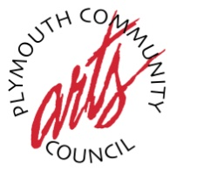
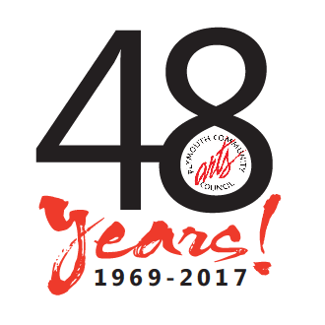
Open Exhibit Artist Registration Form

The Artist
Name:_____________________________________________________________
Address: ___________________________________________________________
City:____________________________________State:__________Zip:________
Phone:_________________________ Email:______________________________
Current PCAC Member: YES NO RENEWED ______________

ENTRY 1
Title:______________________________________________________________
Media: _______________________________________Price: ________________

ENTRY 2
Title:______________________________________________________________
Media: _______________________________________Price: ________________

Each entry must be properly labeled on back of item and wired for hanging.
The $25 fee includes no more than TWO (2) entries from each artist. Artwork sold during the
exhibit is subject to a 70%/30% commission split with the PCAC. Artwork should be dropped off at the
Plymouth Community Arts Council, 774 N. Sheldon Road, Plymouth, MI 48170
For more information: (734) 416-4278 or email: lisa@plymoutharts.com
www.plymoutharts.com

