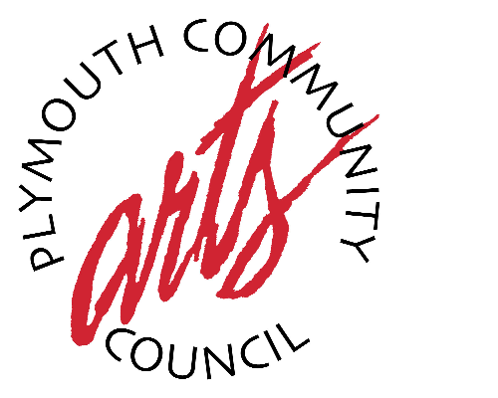

Call For Entries
“From The Inside Out”
A Photography Competition and Exhibit at the Plymouth Community Arts Council
Showing in the Main Gallery July 10 - August 18, 2017

The Plymouth Community Arts Council announces a call for photographs for a July 2017 Main Gallery Exhibit, “From The Inside Out”. The community open competition and exhibit are inspired by “The Window” by Henri Matisse, displayed at the PCAC as part of the DIA’s Inside/Out Program. Inside/Out is made possible by The Knight Foundation
Prizes will be awarded in three categories: Student, Adult Amateur and Adult Professional. All entries will become our July-August Main Gallery Exhibit.
Submitted photos should show both the inside and outside of a space, with a window! Please refer to the painting for inspiration, but feel free to show your creativity! Photos may be color or BW, size 8 x 10 or larger, and must be framed for hanging. Photos must be labeled on the back with artist name, category, address, email and phone number. All must be accompanied by a signed entry form (available on site during the month of June 2017, and $10 entry fee.
Photos may be dropped off from June 19-June 30 at the Plymouth Community Arts Council during office hours, 9:00am-4:30pm Monday-Friday, or by appointment after business hours by emailing lisa@plymoutharts.com
The show will be judged by Barbara Heller, DIA Director of Special Projects, and Lisa Howard, PCAC Executive Director.
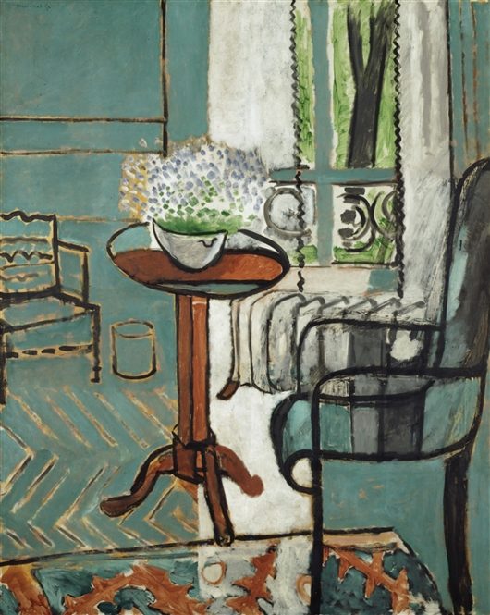
A Gallery Open House featuring "From The Inside Out" photography
will be held on Saturday, July 8th from 2:00pm – 5:00pm.
The event is free and open to the public. Refreshments will be served.

EXPERIENCE ART this weekend all over Downtown Plymouth!
Visitors to the gallery can pick up Plymouth’s Art in The Park Festival
Program and map, as well as DIA Inside Out Art maps, and Pocketsites
mobile tour App download instructions.

Contact: Lisa Howard, PCAC Executive Director
lisa@plymoutharts.com 734-416-4278
"The Window" by Henri Matisse

Plymouth Community Arts Council 774 N. Sheldon Road Plymouth, MI 48170
www.plymoutharts.com

